SMART FASHION RECOMMENDER APPLICATION

A PROJECT REPORT

Submitted by

A.Ajitha(912319104001)

G.Pooja(912319104027)

M.Reka(912319104030)

P.Vaishali(912319104045)

In partial fulfllment for the award of degree of Bachelor of Engineering (B.E) in Computer Science and Engineerring

SACS MAVMM ENGINEEGING COLLEGE

ANNA UNIVERSITY NOVEMBER 2022

## ACKNOWLEDGEMENT

We would like to express our special thanks of gratitude to our Faculty Mentor and Industry Mentor for their support and guidance in completing our project on the Smart Fashion Recommender Application.

We would like to extend our gratitude to the IBM for Nalaiya Thiran project for providing us with all the facility that was required.

It was a great learning experience.We would like to take this opportunity to express our gratitude.

**TEAM MEMBERS: DATE:**

**18/11/22**

A.Ajitha(912319104001

G.Pooja(912319104027)

M.Reka(912319104030)

P.Vaishali(912319104045)

## TITLE

1. ABSTRACT
2. INTRODUCTION
3. HISTORY AND OVERVIEW
4. RECOMMENDATION SYSTEM
5. LITERATURE REVIEW
6. METHODOLOGY
   1. LEARNING PHASE
   2. RECOMMENDATION PHASE
   3. CHANNELS OF SCHOLARLY DISSEMINATION RELATED TO FASHION RECOMMENDATION SYSTEM
7. PROJECT PHASE
   1. PHASE 1
   2. PHASE 2
8. PROJECT DEVELOPMENT PHASE a.LOGIN PAGE
9. HOME PAGE
10. CHAT BOT
11. FEEDBACK
12. DISCUSSION
13. CONCLUSION
14. FUTURE SCOPE

### ABSTRACT

In recent years, the huge amount of informaton and users of the internet service, it is hard to know quickly and accurately what the user wants. This phenomenon leads to an extremely low utlizaton of informaton, also known as the informaton overload problem. Traditonally, keywords are used to retrieve images, but such methods require a lot of annotatons on the image data, which will lead to serious problems such as inconsistent, inaccurate, and incomplete descriptons, and a huge amount of work. To solve this problem, Content Based Informaton Retrieval (CBIR) has gradually become a research hotspot. CBIR retrieves picture objects based entrely on the content. The content of an image needs to be represented by features that represent its uniqueness. Basically, any picture object can be represented by its specifc shapes, colours, and textures. These visual characteristcs of the image are used as input conditons for the query system, and a result the system will recommended nearest images and data set. This research designs and implements two-stage deep learning-based model that recommends a clothing fashion style. This model can use deep learning approach to extract various atributes from images with clothes to learn the user's clothing style and preferences. These atributes are provided to the correspondence model to retrieve the contguous related images for recommendaton. Based on data-driven, this thesis uses convolutonal neural network as a visual extractor of image objects. This experimental

model shows and achieves beter results than the ones of the previous schemes.

Recommendation systems are the techniques that are used to predict the rating one individual will give to an item or social entity. The items can include books, movies, restaurants and things on which individuals have different preferences. These preferences are being predicted using two approaches frst content-based approach which involves characteristics of an item and second collaborative fltering approaches which considers user's past behaviour to evaluate its choices. This thesis proposes a fashion recommendation system which will recommend clothing images supported the style sort of the provided clothing images. In this work, we focus on the images of upper body as well as

the lower body clothing and with human model in the images. We have created our own datasets through web scrapping of different ecommerce websites. In this paper we have come up with an idea to build a content-based recommendation system using ResNet-50 convolutional neural network.

**Keywords**: Cloth Recommendation, Convolutional Neural Network, Similarity Measure.

# Introduction

During the last years, online shopping has been growing. In 2013, the total turnover for ecommerce in Europe expanded with 17% in contrast to the 12 months before and huge organizatons can have hundreds and hundreds of products or even more from which we can select on websites. Both the customer and the business enterprise desire the client to easily discover applicable products or items both throughout search and when they are searching, and this is where recommender systems come into the picture. The greater part (62%) of US buyers with Web access presently shop on-line, to some degree, at least a month, and 1% say they do not buy from internet, as indicated by a current report by Walker Sands. From all the clients looking for items on the web, 63% of them buy garments (Burke, 2002), these being, quite possibly, the most purchased items. The informaton uncover that women are more likely to buy on-line, with 71% of ladies doing this, contrasted with 52% of men. Studies on clothing are in a growing development in general as a result of the tremendous market related to dress. In China, the serviceable market crushed 20 billion US dollars in 2016. Picture recovery can be depicted as the errand of looking out for pics in a picture data set. This is present not an astute thought, in light of everything. It has been explored on account of the way that the 1970s joined informatonal collecton associatons with PC vision, looking into the issue as indicated through two uncommon perspectves, the frst being text-based and the second one being visual-based. From the outset, the developments have been made only through informaton annotatons that have been saved in a database to work the retrieval step, however, when the dimension of the image collectons started to amplify the efort required to label them used to be as soon as unsustainable, to solve this issue, during the 1990s, content-based photograph retrieval was proposed. Startng now many

searched for lines have seemed the use of one or the diferent isolated or combining them. Recommendaton systems make recommendatons based on the informaton they are provided with and in the manner in which they are programmed. Going into details, most of the evaluaton applied is independent coming up with a brand-new recommendaton algorithm, system, or model. However, diferent researchers use already existng work as researchers use an already existng current piece of work to come up with a new diagram or to truly improve the current one. The present analysis model focuses on the use of a current algorithmic program and, consequently, the use of a new research concept comes up with a recommender system. Existng research and fashions have given us some inspiratons of how to design fashion recommendaton systems. Nevertheless, they also involve some common drawbacks. Therefore, in this study, our aim to suggest a new method to assist personal choice making through supplying images and get suggestons based on provided contents.

#### The contributon of the research are follows:

* To design and implement a web-based clothing fashion style recommender system based on deep learning;
* A scheme for improving a person’s clothing style by removing the features he/she doesn’t like.
* These atributes served to a similar model to retrieve similar images as recommendatons.
* Combined with more common content-based recommendaton systems, our model can help to extend robustness and performance.

**Literature survey**

#### Myntra-Matching Clothes Recommendation:

On selecting a particular item to buy, Myntra automatically suggests a full set of clothes that are matching to the selected item. For example, on selecting a particular t-shirt, the system automatically generates a combination of watches, shoes, pants, etc. that are matching to the selected t-shirt. This system does not take into consideration private qualities of customers like skin color and existing clothes. It will only suggest clothes that already exist in its database.

#### Your Closet:

This is a mobile application that organizes the closet. The user interface is shown in. The application asks customer to input their clothes. It then matches each cloth with other clothes. For example, if there are 4 shirts and 4 pants, the application matches each shirt with each pant and thus provides 16 possibilities. The application does not make matches of clothes depending upon patterns, color and texture of clothes. It also does not have a recommendation system.

#### Your Closet App Magic Closet:

This system aims to retrieve clothes from online stores that are matching to the input clothes. These clothes must be ft to a particular occasion. In this system, the user takes a photo of them specifying if they want to use the top or bottom clothes along with the occasion they want to use it for. The system will search for clothing that matches the user query and satisfes the criterion of wearing aesthetically and wearing properly.

#### Which Clothes to wear confdently?:

The basic problem the system addresses is: From the two given images corresponding to a pair of clothes, we have to determine if the pair of clothes matches or not. While there may be several aesthetics espoused by dierent individuals, it takes a simplistic approach in this problem. An example of shirts and ties is used. Various machine learning methods are used to classify if the clothes are matching or not such as Ridge Regression, Standard Neural Network and Siamese Neural Network.

#### Personalized Clothing Recommendation Based on Knowledge Graph:

This system attempts to exploit the knowledge graph for providing clothing recommendations to the user keeping the user context in mind. The recommendation is done by calculating the similarity in the clothing ontology similar to users collection. Skin and Clothes matching seeded by Color System Selection: The main aim of the system is to suggest clothes to user based on skin color. The paper frst fnds out which color scheme is best suited to represent skin colors and then tries to fnd a way to recommend if clothes and skin color match. An automated system to determine the highest levels of color

suitability between skin and clothing was made.

#### Discerning Advisor:

The system tries to recommend clothes based on skin olor of the customer. Using a neural network, frst the skin color is detected. Fuzzy logic is used to map a skin color to the skin color of a fashion model, and clothes suited to that model are recommended. Garment Detectives: The garment detection is to detect the presence of clothes in images and somewhat locate their extents, where the localization can be defned from coarse (image) level to fne (pixel) level. A unifed system is proposed for detecting and recognizing clothes in customer photos.

#### Identifying Corners of Clothes by Image Processing:

This system aims to fnd the edges of the clothes for clothes manipulation. This system achieves this by fnding pixels that represent the clothes. This system frst accepts user image and then performs several image processing operations to improve the efciency of edge detection. It then uses certain criterion to decide whether a pixel represents an image or not.

#### Real-time Clothing Recognition from Surveillance Videos:

It is an analysis system of contents of video which is capable of tagging various clothes of different persons is created. First, face detection and tracking is performed and each frame is aligned. The system then proceeds to clothing segmentation using a variant of region growing method. Through this, clothes are detected. The system then proceeds to clothing recognition and indicates the type of clothing – skirt, t-shirt, etc.

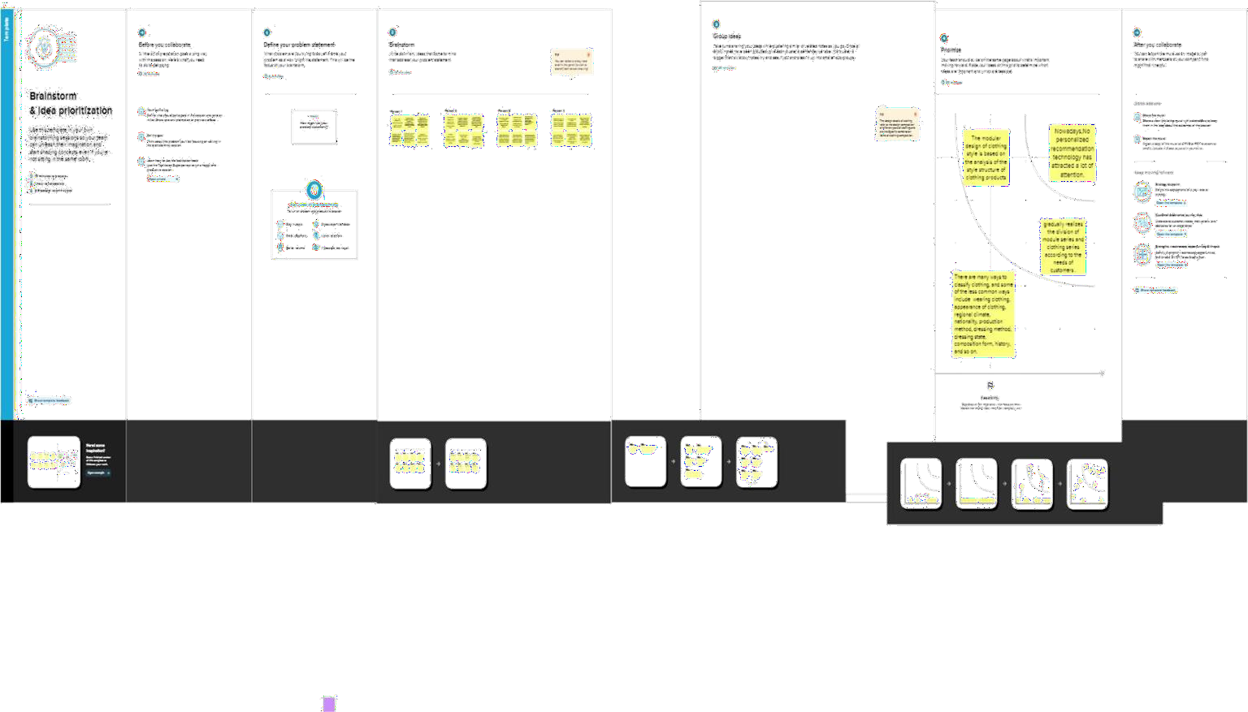

# Proposed system architecture

The system architecture defnes the hardware, sofware and network environment of the structure. The system will be web-based meaning that the users need to run the URL in order to run the system. The system will run both horizontally and vertcally. The architecture used in the system is shown horizontally where the Model View Controller is explained as represented in Figure 1. The high- level part of the system is looked at using the vertcal way.

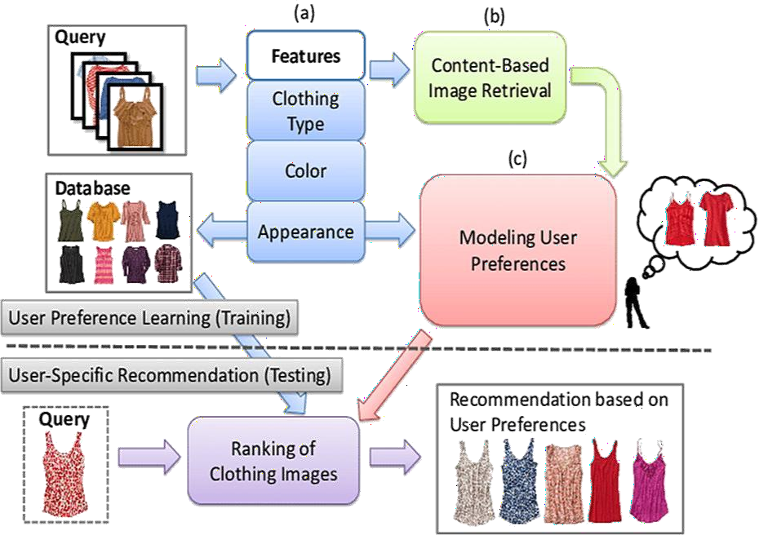

Figure 1. **System architecture**.

The system comprises of the Client tre, which is the front end or View mode, middle ter which is the system controller and the backend tre which is the model. The client side is where the users/customers log in in the system, browse for the system interface, provide input query image to the system, and get recommendaton according to the input query.

The middle true is responsible for communicaton between the front end and the back end. It receives user requests and sends them to the back end and in turn accepts responses from the back end and sends them to the user. The internet works to provide access to the site with a strong security check, provided by both frewall and password protecton policy.

Any unauthorized access is detected and prevented by the frewall.

#### The vertical classifcation system model

The recommendaton system works with the data set to track user input data features and extracted features from data set upon which new predictons and recommendatons are made. The recommendaton browses the dataset for user data and available dataset features. Receives Recommendatons User Web Server Sends response to user Database Stores User input data Stores dataset features.

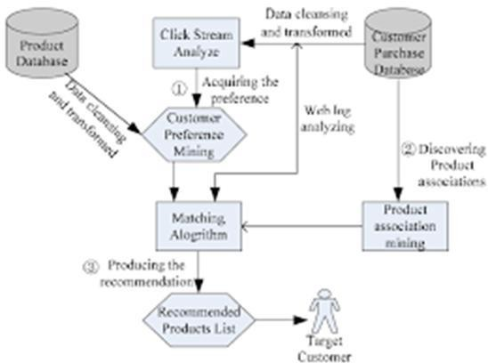

Data Recommender Makes Recommendatons Recommender Algorithm Determines the Similarity between cloths Figure 2. Vertcal architecture of the system. It uses the algorithm to go over the input user data and determine similarites between users input data and stored dataset features. Finally, it makes recommendatons. By looking at Figure 1 and Figure 2, we realize that the recommender system does not interact directly with the users at any point. When the repository stores data, the recommender flters the data it needs from the repository using the algorithm. When a signal is sent to the algorithm about what data are needed for fltering, the algorithm

computes the similarity. The similarity results are then transferred to the recommender system which in turn sends recommendatons to the webserver and fnally to the respectve user.

#### Dataset and classifcation

In this project, we worked with the Deep Fashion dataset, which is gathered from researchers from the Chinese Hong Kong University. It has over one million diverse trend pics and wealthy annotatons with additonal data about landmarks, categories, pairs etc. The dataset consists of 5 distnct types of predictng subsets that are tailor-made towards their tasks.

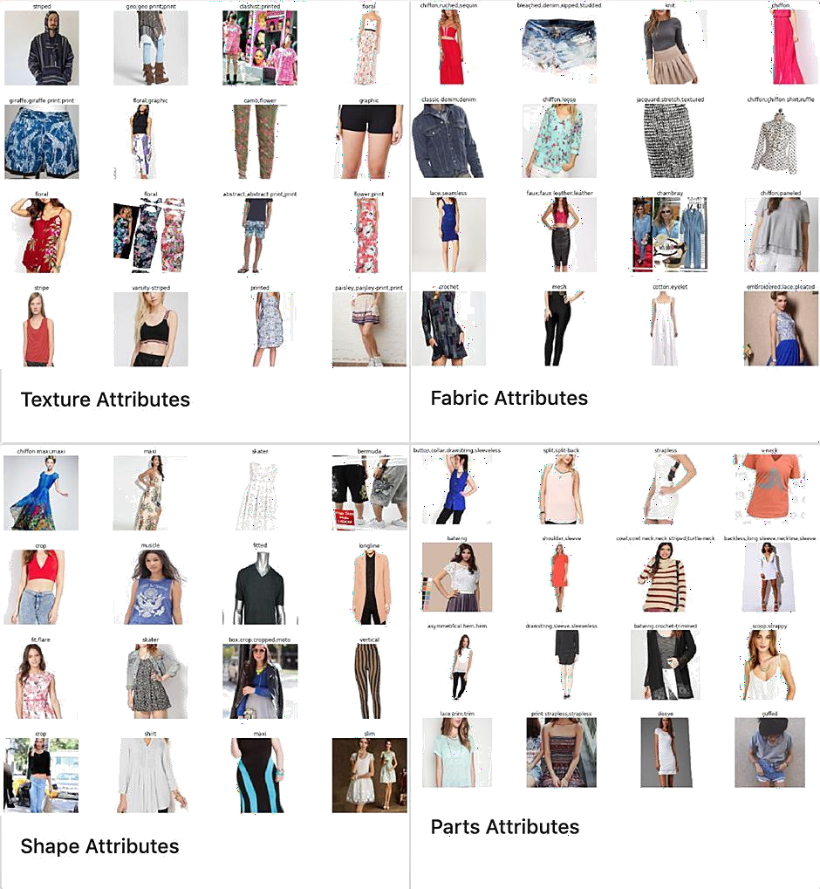

Figure 3. Fashion dataset One subset, known as Atribute Predicton, can be used for apparel category and atribute predicton. From almost 290,000 photos of 50 apparel categories and 1,000 apparel atributes, we randomly picked 18k images from diferent categories and then we classifed them for training and testng. The distributon of labels is presented in Figure

* 1. **Design of deep learning module**

There are many classifcaton algorithms or classifers in use today. The most notably and the most implemented classifers and feature extractor are implemented to solve a problem of cloth / fashion recommendaton Design process. (1)are weight vectors, are fully connected output layers that actually perform classifcaton and are the CNN without the last layer. They are used as a feature extractors.

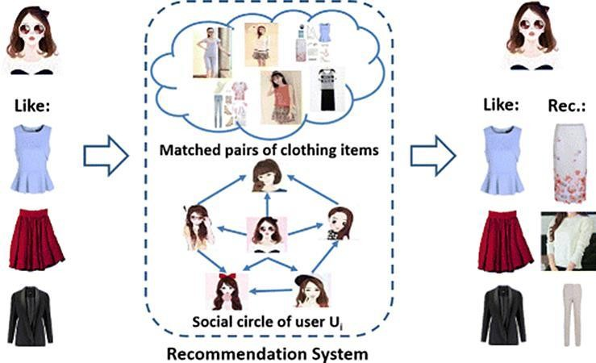

The core network of our model as shown in Figure 4. who presented a convolutonal neural network in the paper “Very Deep Convolutonal Networks for Large-Scale Image Recogniton”, at the University of Oxford.”. Then model is checked for top-5 accuracy on ImageNet.

# Results and Evaluation

This secton focuses on evaluatng our system and deciding the stage which it is able to fulfl the purpose for which it was created the performance of the system is analysed in detail through several tests, from small scale to large scale. Firstly, the unit tests are done at the lower stages and then we proceed to the whole test system. In the training implementaton module, we are performing the movement throughout the area, freeze the base layers of the organizaton i.e., the VGG16 layers, and train the model on the dataset for 5 epochs. This trains the external layers to fgure out how to characterize the pictures. We then unfreeze the lower layers and train the model for 5-7 epochs untl the approval exactness setles. We keep the best achievable loads (best on approval exactness) and use it for the suggeston model. The training implementaton code is presented below.

**Step 1**: Training the whole network for 5 epochs frst

**Step 2**: Checkpoint_callback=modelcheckpoint(‘, /model/vgg_weights_best_patern.hdf5’. **Step.3**: Monitor=’val_acc’, verbose=0 save_best_only=true, save_weights_only=false, mode=auto’, period=1)

**Step 4**: Tf_model.ft_generator( Train_generator, Samples_per_epoch=nb_train_sample, Nb_epoch=10, Validaton data=validaton_generator, Nb_val_samples=nb_validaton_samples, Verbose=1, Inital_epoch=5, Callbacks=[checkpoint_callback]

**Step 5**: end

#### 1. Visual recommendation module implementation

To get proposals, we wished to construct a vault of pictures. This archive would be a unique applicaton. If the suggeston was cultvated for shopping, the storehouse would have contained pictures from online retail locatons like Amazon, eBay, Pinterest, Instagram, etc. A subset of patern datasets was used to test our proposed approach. At that point, the informaton had already been cleared of unimportant photos. Then, the photos were passed by means of the organizaton and design vector pictures have been created from each photo. For the getng the suggeston, we frst needed to build the

individual style profle. This is brought out by taking one or more noteworthy pictures of the client's ideal atre things as they were entered and by making their style vector. These vectors are then blended to shape the framework of the individual style profle. The Figure 5 shown Patern recommendaton with similarity score.

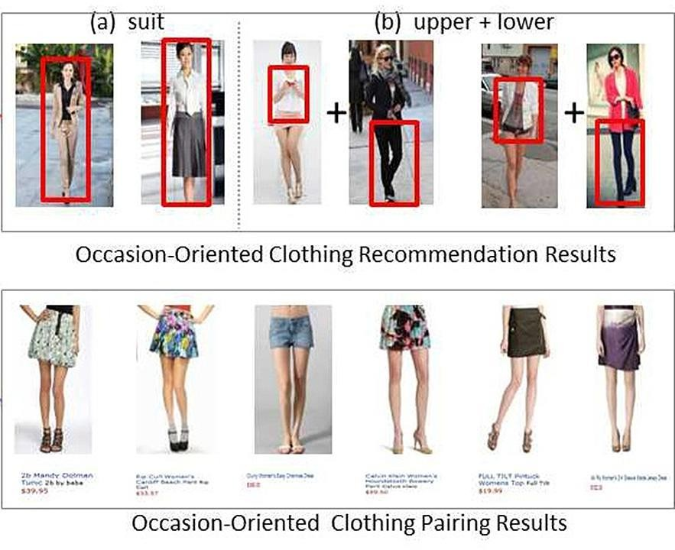

#### Figure 5. Patern recommendaton with similarity score

The proposed scheme is further below, as follows: we will utlize a closeness calculaton, which and the design vector of each picture in the vault with the style profle grid. This gives us a score dependent on the quantty of component coordinates (i.e., how

great is the degree of similarity of a picture to the individual's style profle).

**Step 1**: def similarity (feature_data, inp_ feature_data):

**Step 2**: nun_samp=inp_feature_data. size

**Step 3**: print (unm_samp) Sim_score = [] for i in range (1 en (feature_data)): score=0

**Step 4**: show_sample (data_images[i])

**Step 5**: print (feature_data[i]) score _m = inp_feature_data - feature_data[i]

**Step 6:** print (Soore_ m) score= nun_samp-np. Count_nonzero (score_m) sim_score [i]=score

**Step 7**: print (score) sim Score

**Step 8**: end

#### User management services:

The system provides a platorm through which a user can visit the system and provide his/her choices regarding the fashion images for best recommendaton.

#### Fashion vector for images in repository and input fashion vector:

The system is responsible for making fashion vectors for images in the repository and fashion vector images provided by the user to the system, for the similarity measures and for making recommendatons. Afer making the fashion vector, some predictons are made, as illustrated The system is responsible for making recommendatons to users based on their user data. The user data compiled in the dataset is fltered by the recommender system through the recommender algorithm.

**Step1:**Def similarity (feature_data, inp_feature_data); Num_samp=inp_feature_data.size **Step2:** print (num_samp) Sim_score = () For i in range (len (feature_data)); score = 0 show_sample (data_images[i]) print(feature_data[i]) Romanian Journal of Informaton Technology and Automatc Control, Vol. 31, No. 4, 123-136, 2021 131 [htp://www.rria.ici.ro](http://www.rria.ici.ro/) **Step3:** Score_m inp_feature_data-feature_data[i] print (score_m)

**Step4**:Score=num_samp-np.count_nonzero(score_m) Sim_score[i]=score print(score)

**Step 5**: Return sim_score

**Step 1**: Similarites=similarity(feature_data,inp_feature_data)

**step.2**.items(),

key=operator.itemegter(1), reverse=(true)

Num_reco=30 data=feature_data.size

For I in range(num_reco) Ind = sorted_similarites[i][0]

print (sorted_similarites)

Print (“score:”, sorted_similartes[i][1]) Show_sample(data_images[ind])

**Step 3:** end

By accessing the system, users are able to access and view their content- based recommendatons. However, all the recommendatons are made based on the similarity between user inputs and user inputs. As long as there is a level of similarity, we make the best recommendatons.

#### Recommender to the query images in dataset:

We can see that our model can capture the best matching style by including the length, shape, colour, fabric and patern of the cloths, as illustrated in three query images examples. In the frst example, the model captures deep features including the blouse category, fabric, repeated foral patern and the regular ft style. As seen, the fve recommended images display diferent clothes. The second example shows that the model captures the wool fabrics, the contrast colour sttches and the turtleneck. The third example shows that the model can capture the coton fabrics and the printed leters. The recommendatons can be seen in Figure.

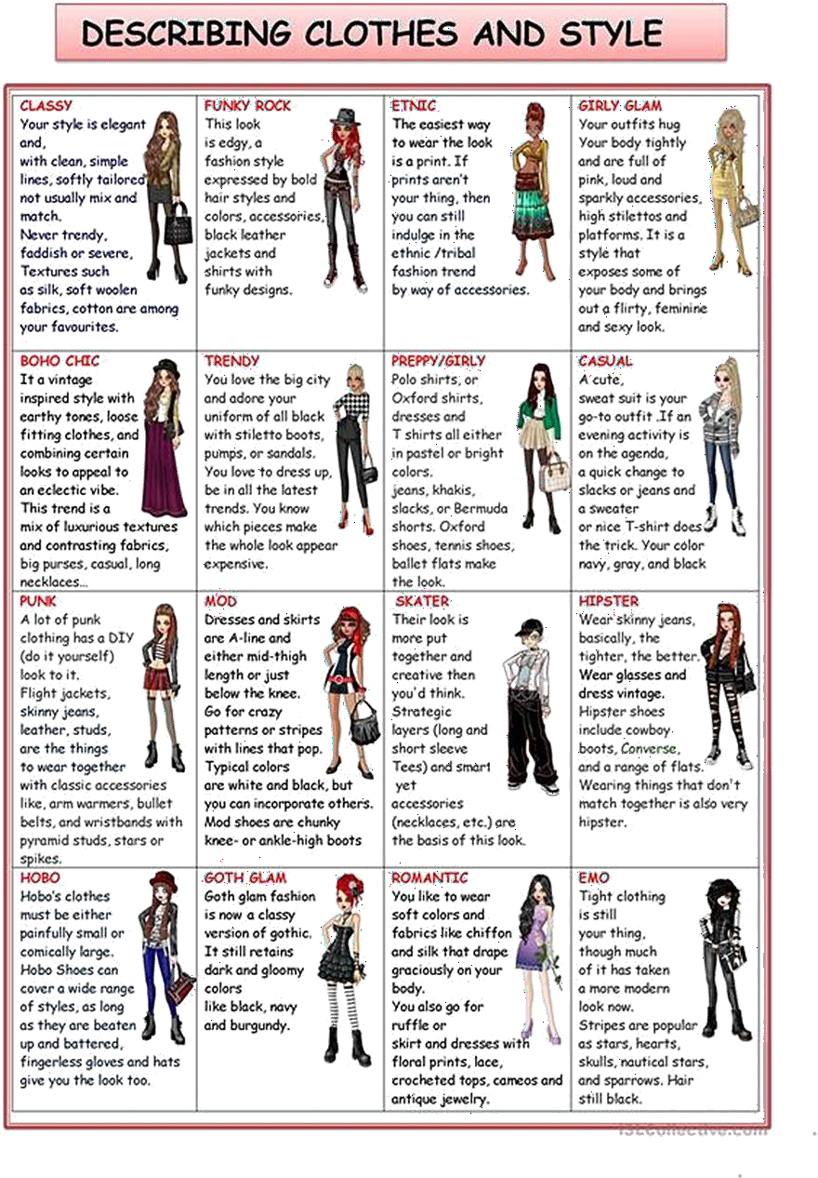

As shown in Figure, our model can capture the style with high accuracy, meaning that our system achieves its purpose. It can be notced that our system can perform for all the involved categories like patern, style, fabric etc. The highest similarity score shows that the input images and the recommended ones are similar. This fgure also illustrates that the system can work best for patern recommendaton and recommend top similar images in diferent colours, shapes, and styles.

#### Recommendations to the query images outside the dataset:

It’s natural to ask if the model you made works with images which are not part of the dataset. We randomly downloaded three online images illustratng expensive clothes. As shown in Figure 8, the model is stll able to capture the style, patern and fabrics of the clothes and recommend similar ones.

The model is checked for diferent categories like patern, style, fabric. The highest score show that the image is more similar to the input query. So, our model obtains high similarity score for diferent categories.

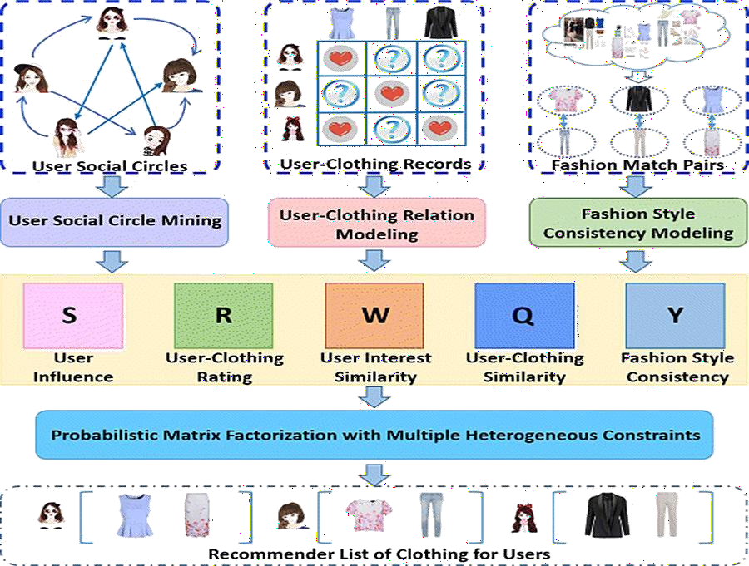

#### Figure: Outside recommendaton dataset

**System result and accuracy:**

Finally, this subsecton evaluates the system and shows the testng results and the accuracy of our model. Afer adding the model on top of the convolutonal base, freezing the weights of all layers except of the top ones, and training the model for 5 epochs, the following accuracy was obtained, as shown in Figure.

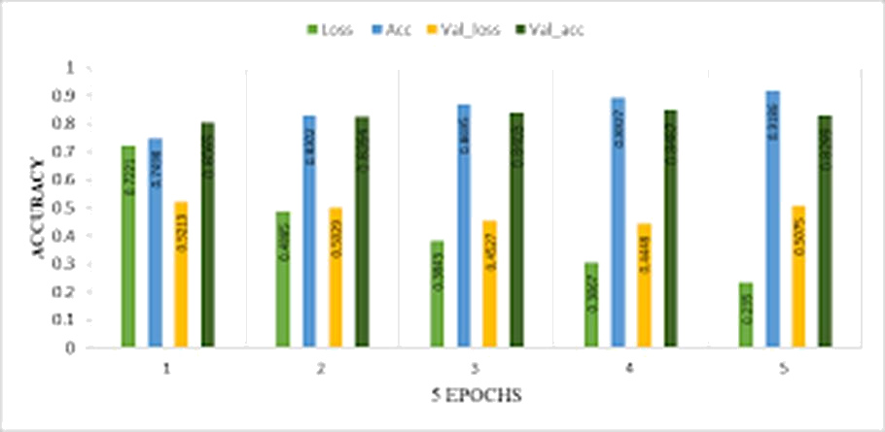

**Figure 9. Model accuracy afer freezing the layers for 5 epochs**

Afer calculatng the mean accuracy for 5 epochs, the obtained results are as follows:

Validaton: accuracy = 0.836000; loss = 0.489109

This part of the sentence “Afer calculatng the mean accuracy for 5 epochs” is mentoned also below, afer Figure 10, and these values mentoned for accuracy and

loss (0.836000 and 0.489109) are not illustrated in Figure 9, but in Figure.

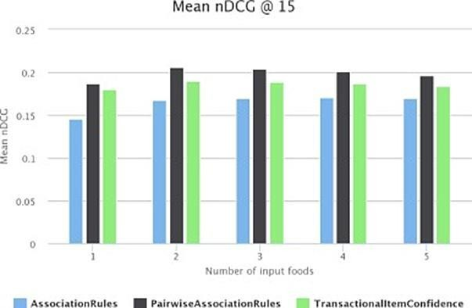

#### Figure 10. Model accuracy for 5 epochs

Afer calculatng the mean accuracy for 5 epochs, the fnal result are as follows: Validaton: accuracy = 0.864750; loss = 0.516400 These values mentoned for accuracy and loss (0.864750 and 0.516400) are not illustrated in Figure 10.

The accuracy of our model was compared with the one of Alex Net model. It can be clearly notced that our model gives a beter accuracy when compared to Alex Net, as shown in Figure 11.

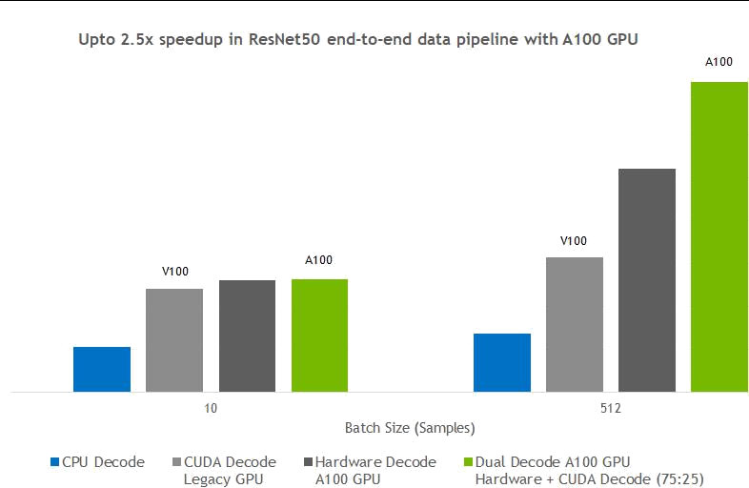

Figure 11. Accuracy and loss

Recommender systems are stll developing and, as extra research is being done, extra areas and weaknesses that need greater study are also developing. Recommender systems have proved to be a great soluton to the overload of web data, an important problem afectng the users. With the ever-growing records and choices, recommender systems enable the customers to access the data they need within minutes, just by a mere mouse click or by a single key stroke. Table 2 shows the comparison with other models regarding the accuracy and the loss values.

**fashion.html**

**Source Code**

<html>

<head>

<meta name="viewpoint" content="width=device-width, inital-scale=1.0">

<ttle>FASHION VIBE</ttle>

<style>

*{ margin: 0;

padding: 0;

font-family:"Century Gothic", CenturyGothic, AppleGothic, sans-serif,'Courier New', Courier, monospace;

box-sizing: border-box; background: fxed;

}

.footer

{

width:100%; height: 20%; display:fex;

background:#121212; margin-top: 5%; color: #7DE5ED; padding-lef: 22%;

align-items: center; text-align: center;

}

.hero{

width: 100%; height: auto;

background-color:#8f8f8f; color: #525252;

}

nav{

background: #7DE5ED; width: 100%;

padding: 10px 10%;

display: fex;

align-items: center;

justfy-content: space-between;

positon: fxed;

}

.logo{

width:200px;

height:50px;

text-decoraton:none; text-align: center; color:#001128;

}

.user-pic{ width: 40px;

border-radius: 50%; cursor: pointer; margin-lef: 30px;

}

nav ul{

width: 100%; text-align: right; font-weight: bold;

}

nav ul li{

display: inline-block; list-style: none; margin: 10px 20px;

}

nav ul li a{

color: rgb(252, 252, 5);

text-decoraton: none;

}

.Banner

{

foat:lef; width: 100%;

height: 400px;

background-color: #121212;

color: #7DE5ED; margin-top: 10%; text-align: center;

}

.Bannerimg1

{

foat: lef; width:50%; height: 400px;

background-color: #525252;

}

.Bannerimg2

{

foat: right; width:50%; height: 400px;

background-color: #525252;

}

.Adcontent

{

width:45%; height: 400px; margin-lef: 55%; color: #7DE5ED; text-align: center; padding: 100px;

}

.Adcontent2

{

width:45%; height: 400px; margin-lef: 5%;

color: #7DE5ED; text-align: center; padding: 100px;

}

.columnst { foat:lef; margin-lef:7%;

margin-top: 10%;

width:230px; height:400px;

background-color:transparent;

border: 2px solid #74bde0; border-color:transparent;

}

.column { foat:lef; margin-lef:7%;

margin-top: 10%; width:230px; height:400px;

background-color:transparent; border: 2px solid #74bde0; border-color:transparent;

}

.columnend

{

foat:lef; margin-lef:7%;

margin-top: 10%;

margin-botom: 10%; width:230px;

height:400px;

background-color:transparent; border: 2px solid #74bde0; border-color:transparent;

}

.Botom

{

height:50px; width:230px;

text-align: center; margin-top:300;

background: #000000e8; color: rgb(252,252,5); padding: 5%;

}

.depimg

{

foat:lef; width:228px; height:300px;

background-color:transparent; border: 2px solid #74bde0; border-color:transparent;

}

.image

{

width: 100%;

height: 100%; object-ft: contain;

}

.search{

width: 330px; margin-lef: 40%; color: #7DE5ED; positon:fxed;

}

.srch{

width: 200px; height: 40px;

background: #7DE5ED;

border: 2px solid #121212; margin-top: 13px; margin-right:13px ;

color: #FCE700;

font-size: 16px;

align-items: center; padding: 10px;

border-botom-lef-radius: 25px;

border-top-lef-radius: 25px; border-botom-right-radius: 25px; border-top-right-radius: 25px;

}

.btn{

width: 60px; height: 40px;

border: 2px solid #000000dd; background:#000000dd; margin-top: 13px;

color: rgb(252, 252, 5); align-items: center; font-size: 15px;

border-botom-lef-radius: 25px; border-top-lef-radius: 25px; border-botom-right-radius: 25px; border-top-right-radius: 25px;

}

.btn:focus{ outline: none;

}

.srch:focus{ outline: none;

}

.sub-menu-wrap{ positon:absolute; top: 100%;

right: 2%; width: 320px;

max-height: 0px; overfow: hidden; transiton: max-height 0.5s;

}

.sub-menu-wrap.open-menu{

max-height: 400px;

}

.sub-menu{ background:rgb(252, 252, 5); padding: 20px;

margin: 10px;

border-radius: 8%;

}

.user-info{ display: fex;

align-items: center;

}

.user-info h3{

font-weight: 500;

}

.user-info img{ width: 60px;

border-radius: 50%; margin-right: 15px;

}

.sub-menu hr{ border: 0; height: 1px; width: 100%;

background: #525252;

margin: 15px 0 10px;

}

.sub-menu-link{

display: fex;

align-items: center; text-decoraton: none; color: #525252; margin: 12px 0 ;

}

.sub-menu-link p{

width: 100%;

}

.sub-menu-link img{ width: 40px; background: #e5e5e5; border-radius: 50%; padding: 8px;

margin-right: 15px;

}

.sub-menu-link span{ font-size: 22px;

transiton: transform 0.5s;

}

.sub-menu-link:hover span{

transform: translateX(5px);

}

.sub-menu-link:hover p{

font-weight: 600;

}

.hello{

margin-botom: 200px; text-align: lef; positon:absolute; right: 10px;

}

</style>

</head>

<body>

<nav>

<a class="logo" href="MadFinalhome.html"><h2>FASHION VIBE</h2></a> <ul>

<li><input class="srch" type="search" name="" placeholder="TYPE TO SEARCH">

<a href="#"><buton class="btn">SEARCH</buton></a></li>

<li><a href="#">HOME</a></li> <li><a href="#">FEATURES</a></li>

<li><a href="#">ABOUT</a></li>

</ul>

<img src="htps://storagedemo-madzh.s3.jp-tok.cloud-object-

storage.appdomain.cloud/images/profle.jpeg" class="user-pic" onclick="toggleMenu()">

<div class="sub-menu-wrap" id="subMenu">

<div class="sub-menu">

<div class="user-info">

<img src="htps://storagedemo-madzh.s3.jp-tok.cloud- object-storage.appdomain.cloud/images/profle.jpeg">

<h2>NAME</h2>

</div>

<hr>

<a href="#" class="sub-menu-link">

<img src="htps://storagedemo-madzh.s3.jp-tok.cloud- object-storage.appdomain.cloud/images/profle.jpeg">

<p>EDIT PROFILE</p>

</a>

<a href="#" class="sub-menu-link">

<img src="htps://storagedemo-madzh.s3.jp-tok.cloud- object-storage.appdomain.cloud/images/setngs.jpeg">

<p>SETTING & PRIVACY</p>

</a>

<a href="#" class="sub-menu-link">

<img src="htps://storagedemo-madzh.s3.jp-tok.cloud- object-storage.appdomain.cloud/images/help.jpeg">

<p>HELP</p>

</a>

<a href="/Login" class="sub-menu-link">

<img src="htps://cdn-icons- png.fatcon.com/512/56/56805.png"> <p>LOGOUT</p>

</a>

</div>

</div>

</nav>

<div class="Banner">

<div class="Bannerimg1"> <img img class="image"

src="fashionimagebanner.webp"></div>

<div class="Adcontent">

<h1><br>THE JOY OF DRESSING IS AN ART.</br></h1>

<br>Let's have a look on it ></br>

</div>

</div>

<div class="rowstart">

<div class="columnst"> <div class="depimg"><img class="image" src="sarees.webp"> </div> <div class="Botom">WEDDING SAREES</div> </div>

<div class="columnst"> <div class="depimg"><img class="image" src="Salwar kameez.webp"> </div> <div class="Botom">SALWAR KAMEEZ</div> </div>

<div class="columnst"> <div class="depimg"><img class="image" src="Kurts.webp"> </div> <div class="Botom">CASUAL KURTIS</div> </div>

<div class="columnst"> <div class="depimg"><img class="image" src="bridal lehenga.webp"> </div> <div class="Botom">BRIDAL LEHENGA</div> </div>

</div>

<div class="Banner">

<div class="Bannerimg2"> <img img class="image"

src="lovablekidsatre.webp"></div>

<div class="Adcontent2">

<h1 class="kids"><br>LOVABLE KIDS ATTIRE</br></h1>

<br>-------Smiles are always in FASHION </br>

</div>

</div>

<div class="row">

<div class="column"> <div class="depimg"><img class="image" src="Modern vibe.webp"> </div> <div class="Botom">MODERN VIBE</div> </div>

<div class="column"> <div class="depimg"><img class="image" src="festvemood.webp"> </div> <div class="Botom">FESTIVE MOOD</div> </div>

<div class="column"> <div class="depimg"><img class="image" src="skinny dress.webp"> </div> <div class="Botom">SKINNY DRESS</div> </div>

<div class="column"> <div class="depimg"><img class="image" src="Max girls.webp"> </div> <div class="Botom">MAX GIRLS</div> </div>

</div>

<div class="Banner">

<div class="Bannerimg1"> <img img class="image"

src="mensfashion.webp"></div>

<div class="Adcontent">

<h1><br>HANDSOME MEN ATTIRE</br></h1>

<br>Always DRESS well, Keep it SIMPLE but SIGNIFICANT </br>

</div>

</div>

<div class="row">

<div class="column"> <div class="depimg"><img class="image" src="polo t shirts.webp"> </div> <div class="Botom">POLO T-SHIRTS</div> </div>

<div class="column"> <div class="depimg"><img class="image" src="menhoodies.webp"> </div> <div class="Botom">HOODIES</div> </div>

<div class="column"> <div class="depimg"><img class="image" src="men casuals.webp"> </div> <div class="Botom">MEN CASUALS</div> </div>

<div class="column"> <div class="depimg"><img class="image" src="formal shirts.webp"> </div> <div class="Botom">FORMAL SHIRTS</div> </div>

</div>

<div class="Banner">

<div class="Bannerimg2"> <img class="image" src="adornments.webp"></div>

<div class="Adcontent2">

<h1><br>PERSONAL ADORNMENTS</br></h1>

<br>ADORNMENT is never anything except a REFLECTION of the HEART!!!</br>

</div>

</div>

<div class="rowend">

<div class="columnend"> <div class="depimg"><img class="image" src="women ornmanets.webp"> </div> <div class="Botom">JEWELLERY</div> </div>

<div class="columnend"> <div class="depimg"><img class="image" src="watch.jpg"> </div> <div class="Botom">WATCHES</div> </div>

<div class="columnend"> <div class="depimg"><img class="image" src="htps://5.imimg.com/data5/TQ/NK/MY-45888708/men- belts-500x500.jpg"> </div> <div class="Botom">BELTS</div> </div>

<div class="columnend"> <div class="depimg"><img class="image" src="htps://encrypted-tbn0.gstatc.com/images?q=tbn:ANd9GcQSWDKgpQeZ-3VNR7- 9SfaVGVvqOawrkZiLdNfSpjNNQJNI6hl8cJg0Qs_DZfpJtzUst0&usqp=CAU"> </div>

<div class="Botom">HANDBAGS & CLUTCHES</div> </div>

</div>

<script>

let subMenu = document.getElementById("subMenu"); functon toggleMenu(){

subMenu.classList.toggle("open-menu");

}

window.watsonAssistantChatOptons = {

integratonID: "1a8c11c0-839e-4442-8b03-59f7c12ce5f5", // The ID of this

integraton.

region: "au-syd", // The region your integraton is hosted in. serviceInstanceID: "bada3725-51e6-42fe-bccc-3e2603433478", // The ID

of your service instance.

onLoad: functon(instance) { instance.render(); }

};

setTimeout(functon(){

const t=document.createElement('script');

t.src="htps://web-chat.global.assistant.watson.appdomain.cloud/versions/" + (window.watsonAssistantChatOptons.clientVersion || 'latest') + "/WatsonAssistantChatEntry.js";

document.head.appendChild(t);

});

</script>

</body>

<footer>

<div class="footer">

<div class="hello">

<a href="Feedback.html">feedback</a>

</div>

<div >

<H1>THANK YOU FOR PURCHASING. WELCOME AGAIN!!!!</H1>

</div>

</div>

</footer>

</html>

### server.py

from fask import Flask, render_template, request import os

appFlask = Flask( name )

picFolder = os.path.join('statc','images') appFlask.confg['UPLOAD_FOLDER'] = picFolder

@appFlask.route('/') @appFlask.route('/out') def index():

return render_template("login.html")

@appFlask.route('/login',methods = ['POST', 'GET'])

def my_forum_post():

return render_template('FashionVibe.html')

@appFlask.route('/index',methods = ['POST', 'GET'])

def my_forum_posts():

return render_template('index.html')

@appFlask.route('/Feed',methods = ['POST', 'GET']) def my_forum_posts1():

return render_template('Feedback.html')

if name == " main ":

appFlask.run(debug=True)

### fashion.css

{

margin: 0;

padding: 0;

font-family:"Century Gothic", CenturyGothic, AppleGothic, sans-serif,'Courier New', Courier, monospace;

box-sizing: border-box; background: fxed;

}

.footer

{

width:100%; height: 20%; display:fex;

background:#121212; margin-top: 5%; color: #7DE5ED; padding-lef: 22%; align-items: center; text-align: center;

}

.hero{

width: 100%; height: auto;

background-color:#8f8f8f;

color: #525252;

}

nav{

background: #7DE5ED; width: 100%;

padding: 10px 10%; display: fex;

align-items: center;

justfy-content: space-between;

positon: fxed;

}

.logo{

width:200px; height:50px;

text-decoraton:none; text-align: center; color:#001128;

}

.user-pic{ width: 40px;

border-radius: 50%; cursor: pointer; margin-lef: 30px;

}

nav ul{

width: 100%; text-align: right; font-weight: bold;

}

nav ul li{

display: inline-block; list-style: none; margin: 10px 20px;

}

nav ul li a{

color: rgb(252, 252, 5); text-decoraton: none;

}

.Banner

{

foat:lef; width: 100%;

height: 400px;

background-color: #121212;

color: #7DE5ED; margin-top: 10%; text-align: center;

}

.Bannerimg1

{

foat: lef; width:50%;

height: 400px;

background-color: #525252;

}

.Bannerimg2

{

foat: right; width:50%; height: 400px;

background-color: #525252;

}

.Adcontent

{

width:45%; height: 400px; margin-lef: 55%; color: #7DE5ED; text-align: center; padding: 100px;

}

.Adcontent2

{

width:45%; height: 400px; margin-lef: 5%;

color: #7DE5ED; text-align: center; padding: 100px;

}

.columnst { foat:lef; margin-lef:7%;

margin-top: 10%;

width:230px; height:400px;

background-color:transparent;

border: 2px solid #74bde0; border-color:transparent;

}

.column { foat:lef; margin-lef:7%;

margin-top: 10%; width:230px; height:400px;

background-color:transparent;

border: 2px solid #74bde0; border-color:transparent;

}

.columnend

{

foat:lef; margin-lef:7%;

margin-top: 10%;

margin-botom: 10%; width:230px; height:400px;

background-color:transparent;

border: 2px solid #74bde0; border-color:transparent;

}

.Botom

{

height:50px; width:230px;

text-align: center; margin-top:300;

background: #000000e8;

color: rgb(252,252,5);

padding: 5%;

}

.depimg

{

foat:lef; width:228px; height:300px;

background-color:transparent; border: 2px solid #74bde0; border-color:transparent;

}

.image

{

width: 100%;

height: 100%; object-ft: contain;

}

.search{

width: 330px; margin-lef: 40%; color: #7DE5ED; positon:fxed;

}

.srch{

width: 200px; height: 40px;

background: #7DE5ED; border: 2px solid #121212; margin-top: 13px;

margin-right:13px ; color: #FCE700; font-size: 16px; align-items: center; padding: 10px;

border-botom-lef-radius: 25px; border-top-lef-radius: 25px; border-botom-right-radius: 25px; border-top-right-radius: 25px;

}

.btn{

width: 60px; height: 40px;

border: 2px solid #000000dd;

background:#000000dd; margin-top: 13px;

color: rgb(252, 252, 5);

align-items: center; font-size: 15px;

border-botom-lef-radius: 25px;

border-top-lef-radius: 25px; border-botom-right-radius: 25px; border-top-right-radius: 25px;

}

.btn:focus{ outline: none;

}

.srch:focus{ outline: none;

}

.sub-menu-wrap{ positon:absolute; top: 100%;

right: 2%; width: 320px;

max-height: 0px; overfow: hidden; transiton: max-height 0.5s;

}

.sub-menu-wrap.open-menu{

max-height: 400px;

}

.sub-menu{ background:rgb(252, 252, 5); padding: 20px;

margin: 10px;

border-radius: 8%;

}

.user-info{ display: fex;

align-items: center;

}

.user-info h3{

font-weight: 500;

}

.user-info img{

width: 60px;

border-radius: 50%; margin-right: 15px;

}

.sub-menu hr{ border: 0; height: 1px; width: 100%;

background: #525252;

margin: 15px 0 10px;

}

.sub-menu-link{ display: fex;

align-items: center;

text-decoraton: none; color: #525252; margin: 12px 0 ;

}

.sub-menu-link p{

width: 100%;

}

.sub-menu-link img{ width: 40px;

background: #e5e5e5; border-radius: 50%; padding: 8px;

margin-right: 15px;

}

.sub-menu-link span{ font-size: 22px;

transiton: transform 0.5s;

}

.sub-menu-link:hover span{

transform: translateX(5px);

}

.sub-menu-link:hover p{ font-weight: 600;

}

.hello{

margin-botom: 200px; text-align: lef; positon:absolute; right: 10px;

}

### test.js

<script>

let subMenu = document.getElementById("subMenu"); functon toggleMenu(){

subMenu.classList.toggle("open-menu");

}

window.watsonAssistantChatOptons = {

integratonID: "1a8c11c0-839e-4442-8b03-59f7c12ce5f5", // The ID of this integraton.

region: "au-syd", // The region your integraton is hosted in.

serviceInstanceID: "bada3725-51e6-42fe-bccc-3e2603433478", // The ID of your service instance.

onLoad: functon(instance) { instance.render(); }

};

setTimeout(functon(){

const t=document.createElement('script');

t.src="htps://web-chat.global.assistant.watson.appdomain.cloud/versions/" + (window.watsonAssistantChatOptons.clientVersion || 'latest') + "/WatsonAssistantChatEntry.js";

document.head.appendChild(t);

});

</script>

### chat.js

<script>

let subMenu = document.getElementById("subMenu"); functon toggleMenu(){

subMenu.classList.toggle("open-menu");

}

window.watsonAssistantChatOptons = {

integratonID: "1a8c11c0-839e-4442-8b03-59f7c12ce5f5", // The ID of this integraton.

region: "au-syd", // The region your integraton is hosted in.

serviceInstanceID: "bada3725-51e6-42fe-bccc-3e2603433478", // The ID of your service instance.

onLoad: functon(instance) { instance.render(); }

};

setTimeout(functon(){

const t=document.createElement('script');

t.src="htps://web-chat.global.assistant.watson.appdomain.cloud/versions/" + (window.watsonAssistantChatOptons.clientVersion || 'latest') + "/WatsonAssistantChatEntry.js";

document.head.appendChild(t);

});

</script>

## DISCUSSION

This scholarly artcle has provided a comprehensive review of the methods, algorithmic models and fltering techniques used in the recent fashion recommendaton-based research papers. However, this review paper has some limitatons too. Primarily, the focus of this comprehensive review paper was to explore fashion recommendaton-based artcles published in last decade that

explicitly described their frameworks, algorithms, and fltering techniques. To achieve this goal, the artcles were searched using keywords relevant to the topic ttle instead of using the PRISMA technique. However, it did not afect the artcle extracton methodology, because the authors included and studied all the research papers relevant to the research focus. However, future researchers could conduct a systematc literature review on the same topic. The inital keyword searching did not include “garment” and “outit”; however, this did not infuence the search results because we also studied the fashion recommendaton artcles that contained these keywords. The future research can also conduct a review of the datasets that have been used in fashion recommendaton-based research artcles. Additonally, further reviews of fashion recommendaton systems can apply our proposed potental algorithms to any of the available fashion image datasets to evaluate the performance of the recommender systems.

## CONCLUSION

Recommendaton systems have the potental to explore new opportunites for retailers by enabling them to provide customized recommendatons to consumers based on informaton retrieved from the Internet. They help consumers to instantly fnd the products and services that closely match with their choices. Moreover, diferent stat-of-the-art algorithms have been developed to recommend products based on users’ interactons with their social groups. Therefore, research on embedding social media images within fashion recommendaton systems has gained huge popularity in recent tmes. This paper presented a review of the fashion recommendaton systems, algorithmic models and fltering techniques based on the academic artcles related to this topic. The technical aspects, strengths and weaknesses of the fltering techniques have been discussed elaborately, which will help future researchers gain an in- depth understanding of fashion recommender systems. However, the proposed prototypes should be tested in commercial applicatons to understand their feasibility and accuracy in the retail market, because inaccurate recommendatons can produce a negatve impact on a customer. Moreover, future research should concentrate on including tme series analysis and accurate categorizaton of product images based on the variaton in color, trend and

clothing style in order to develop an efectve recommendaton system.

## FUTURE SCOPE

Online selling and purchasing ofer innumerable benefts to both sellers and buyers, and these advantages are also the reasons for the rising scope of eCommerceWell, to put it bluntly, the scope of e-business in the near future looks to be ever-increasing and growing, because the trend has really caught on here. E-commerce giant Amazon is keen to conquer the Indian market and has already invested a great deal, especially with its 49% stake in the Future Group.

Indian online retail giant Flipkart has already opened a few ofine stores and plans more stores in smaller cites. They plan to combine online and ofine stores to maximize their selling potental.Google and Tata Trust have launched a joint program ‘Saathi’ to increase internet and mobile penetraton among rural women.The Government of India is also making a huge push for Ecommerce by providing numerous sops to startups, cyberparks, and so on through its Digital India program.As of now, there are close to 20,000 E-commerce companies in India, with many more expected to join the bandwagon every month.

## REFERENCE

1. Guan, C.; Qin, S.; Ling, W.; Ding, G. Apparel recommendaton system evoluton: An empirical review. Int. J. Cloth. Sci. Technol. 2016, 28, 854–879, doi:10.1108/ijcst-09-20150100.
2. Hu, Y.; Manikonda, L.; Kambhampat, S. What we Instagram: A frst analysis of Instagram photo content and user types. Available online: htp://[www.aaai.org](http://www.aaai.org/) (accessed on 1 May 2014).
3. Gao, G.; Liu, L.; Wang, L.; Zhang, Y. Fashion clothes matching scheme based on Siamese Network and AutoEncoder. Multmed. Syst. 2019, 25, 593– 602, doi:10.1007/s00530-01900617-9.
4. Liu, Y.; Gao, Y.; Feng, S.; Li, Z. Weather-to-garment: Weather-oriented clothing recommendaton. In Proceedings of the 2017 IEEE Internatonal Conference on

Multmedia and Expo. (ICME), Hong Kong, China, 31 August 2017; pp. 181– 186, doi:10.1109/ICME.2017.8019476.

1. Chakraborty, S.; Hoque, M.S.; Surid, S.M. A comprehensive review on imagebased style predicton and online fashion recommendaton. J. Mod. Tech. Eng. 2020, 5, 212–233.